Department of Computer Science and Telecommunication Engineering.

Proposal for thesis entitled

“Analysis of attacks on Cloud Environment & Simulation of DDoS”.

Abstract:

Cloud Computing is considered as one of the rapid growing technologies for it has high flexibility in both usage and application. Cloud Computing is the type of ‘pay as you go’ model which provides solutions of storage, convenient and on-demand access to a shared pool of configurable computing resources. As with any novel technology, cloud computing is subject to security threats, information threats and underlying infrastructure threats. In this research I will find out the threats and vulnerabilities, and analyze all the possible attacks are happening in the cloud. The paper will describe some scenarios of DoS (denial-of-service) attack make some simulations on it. This research will lead us to better understanding about the Cloud Computing vulnerabilities and security threats on it.

1. Introduction

The term **Cloud** refers to a network or internet. In other words we can say that Cloud is something, which is present at remote location. It can provide services over internet on public network or private network. **Cloud Computing** is internet based where shared resources; software and information are provided to computers and other devices on-demand.

According to the National Institute of Standards and Technology (NIST) “Cloud computing is a model for enabling ubiquitous, convenient, on-demand network access to a shared pool of configurable computing resources (e.g., networks, servers, storage, applications, and services) that can be rapidly provisioned and released with minimal management effort or service provider interaction.”[1] This cloud model is composed of five essential characteristics, three service models, and four deployment models.

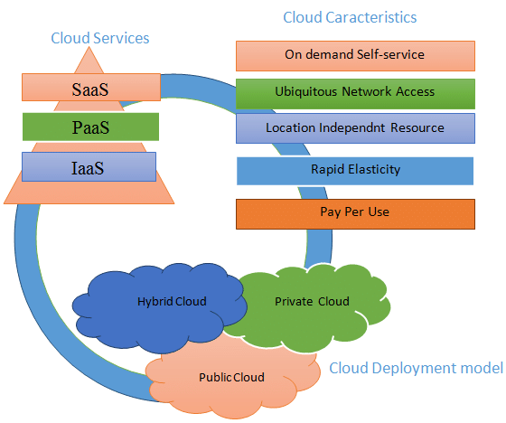

Figure-1: Cloud deployment models, Characteristics, and infrastructures. [2].

REFERENCES:

# Peter Mell Timothy Grance “The NIST Definition of Cloud Computing” NIST Special Publication 800-145, September 2011

# Omar ACHBAROU, My Ahmed EL KIRAM, Salim ELBOUANANI “A survey of Cloud Computing Attacks” December 2014

# Raja Mohamed Jabir, Salam Ismail Rasheed Khanji, Liza Abdallah Ahmad, Omar Alfandi “Analysis of cloud computing attacks and countermeasures” – 2016 [College of Technological Innovations, Zayed University, 144534, UAE]